Owens, Cody

MTM230

Professor Rappleye

Texture Sheets: PBR Explained

The task for this assignment is to describe the different aspects of PBR (Physically-Based Rendering) and what they do in texturing.

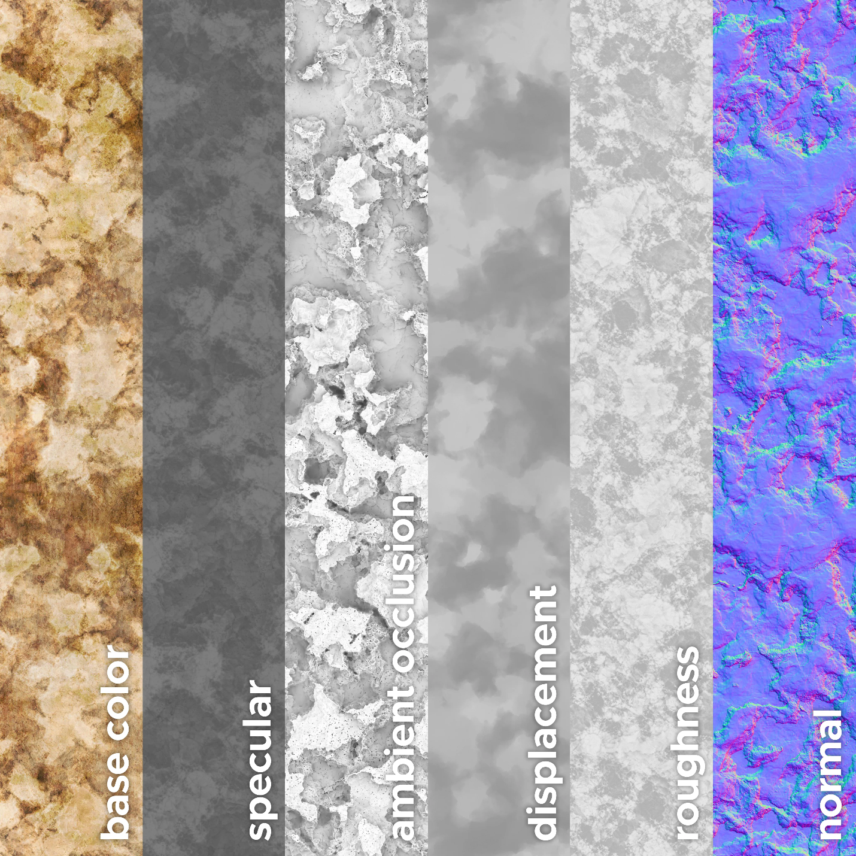

**Base Color**:

This map is the—well—base color of the texture. It is responsible for setting the foundation of color for the object’s texture map.

**Roughness**:

This map shows how rough an object is. For each of these maps that are displayed in a grayscale, black means all and white means none with the grayscale between them representing the other values (0 – 1 Scale). As such, in the roughness map, we can show the *roughness* of an object.

**Metallic**:

This map doesn’t show in the image found above, but its name is self-explanatory enough regardless. This map shows how metallic the surface is. With a 0, all the color shows through from the base color map, 0.5 shows as though the surface is painted, 1 appears like a colored mirror and reflects the environment.

**Ambient Occlusion**:

This map shows how the object reacts to light in the environment. Black shows areas where shadows will be and white usually means that that area is more reflective and would be brighter.

**Normal**:

This map is the weird looking one on most PBR sheets. Normal is responsible for the depth of an object. Think of it like a topographical map of the object.

This source goes more in depth into each of the maps as well as a few specialized maps such as Opacity, Height, Emissive, and Refraction. This source describes the maps found above. Keep in mind that Base Color is replaced by Albedo in the source.

Source:

<https://www.a23d.co/blog/different-maps-in-pbr-textures>